LAB REPORT - EXPERIMENT 2

COEN 316 – Computer Architecture – Winter 2025
Section WC - X

Lab performed on : February 12th 2025
Report submitted on : March 5th 2025

Lab performed and report written by : Simon Guindon – 40058301

TA Instructor:
Umair Hussain

Introduction and Objective
This experiment’s objective is to introduce the experimenter to designing a multi-port register file. We will design the 32 bit version of it, as well as a sized down version so that the code would be physically testable on a Nexys A7 board.
Theory and Results
The usefulness of an multi-port register file is that it can take a 32 bits input and save it to memory until it is requested by the system. As such, it serves as a memory component that lets the user save and load data as required. For example, we can access data at a memory address (the value in either a or b) at the output out_a and out_b respectively, or writing into memory at the address write_address.
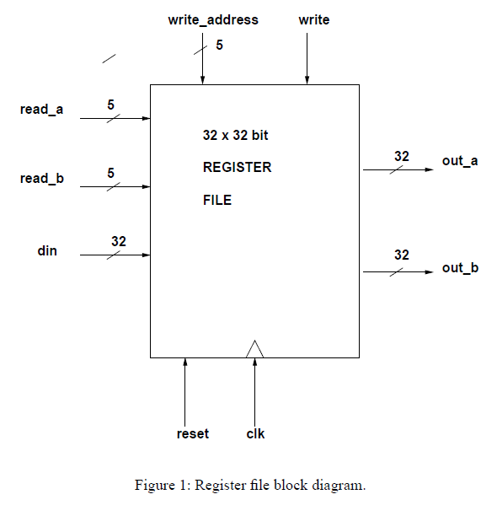

Results
Section 1.1 – Testing ModelSim’s output for regfile.vhd
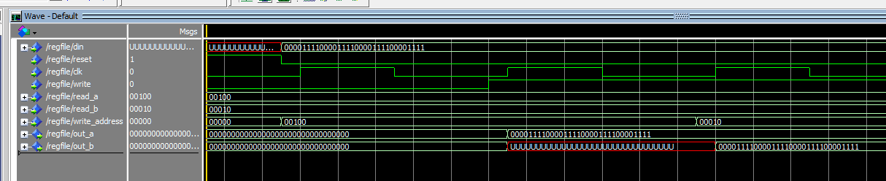
We can see that the code works as intended, because when din is 0000 1111 0000 1111 0000 1111 0000 1111, and that write is set to 1, we write at the address 00100, and set a to read 00100, we see the output at out_a.
Similarly, when we set write_address to 00010, and set b to read 00010, we see the output at out_b.

Section 1.2 – Testing ModelSim’s output for regfile_wrapper.vhd
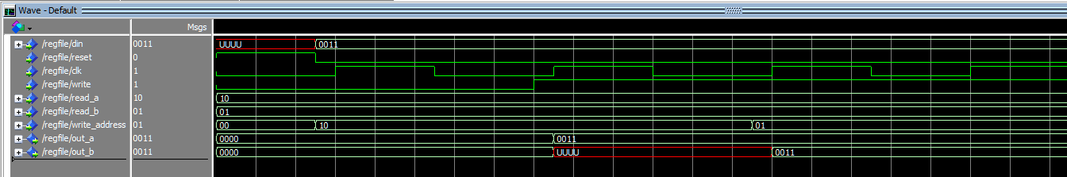
Similarly to above, we can see that the code works as intended, because when din is 0011, and that write is set to 1, we write at the address 10, and set a to read 10, we see the output at out_a.
Similarly, when we set write_address to 01, and set b to read 01, we see the output at out_b.

Section 2.1 – VHDL source code for regfile.vhd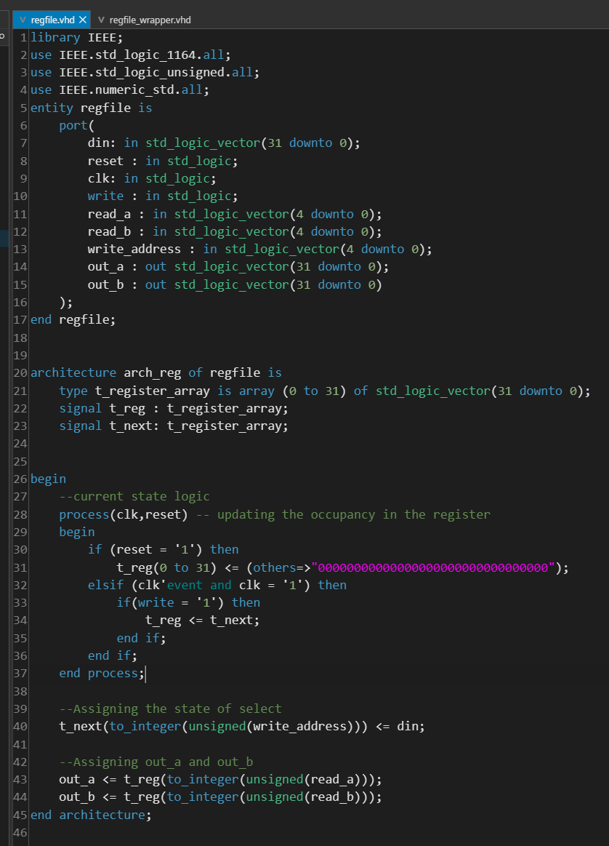
Section 2.2 – VHDL source code for regfile_wrapper.vhd
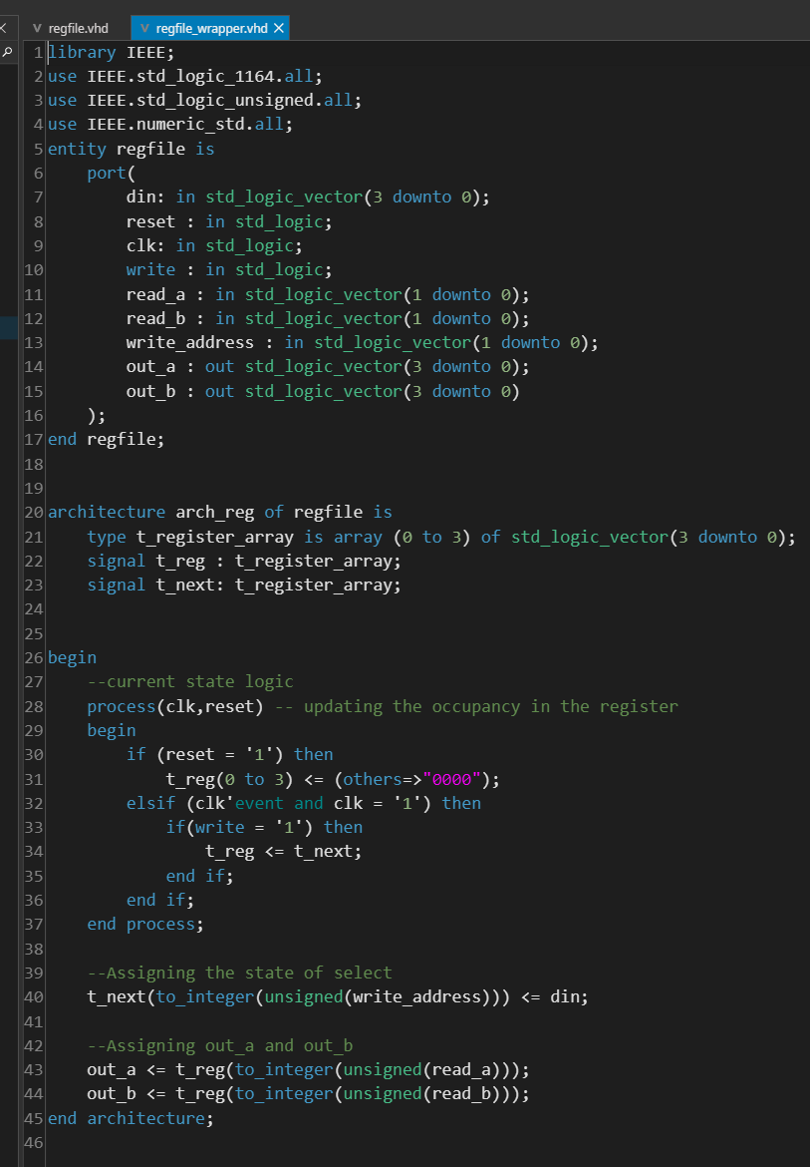
Section 3.1 – Do file for regfile_wrapper.vhd (regfile_wrapper.do)
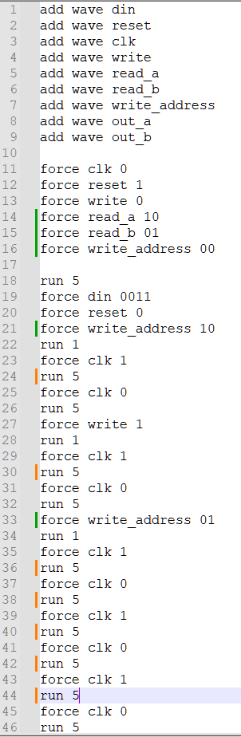

Section 3.2 – Do file for regfile.vhd (regfile.do)
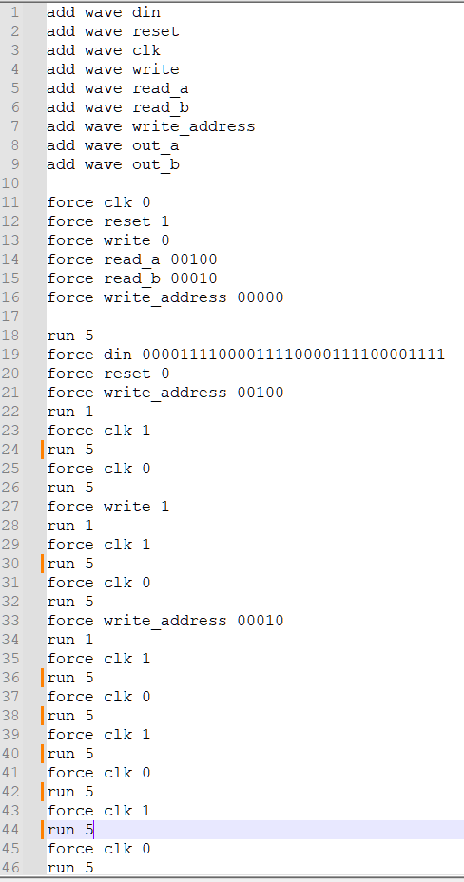
Section 3.3 – XDC file for regfile_wrapper.vhd (regfile_wrapper.xdc)
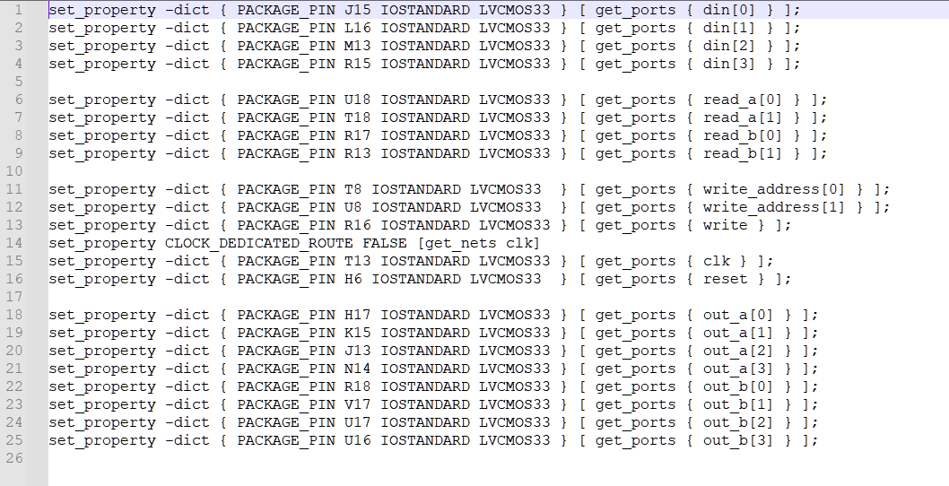
Conclusion
In conclusion we had our first experience building two versions of an register file system, one with a full 32 bits input and a wrapper that can be presented on a Nexys A7 board. The results we obtained were in agreement with the theoretical output for the register file. Future labs will incorporate this register file into more complex systems.

;

